The Enchanted Pool

This story is a part of epic Mahabharata. In this story tells about the **“ADHERENCE TO LAW PRINCIPLE IS IMPORTANT”.**

There are five brothers whose name Yudhistira, Bheem, Arjun, Nakul and Sahadev. Yudhistira and his brothers get lost in the forest chasing a magic deer. The five brothers were getting tired and thirsty. Yudhistira was thirsty and needed to satisfy it. He requested that his brother Nakul go in search of water.

Nakul ascended to the top of the tree and took a look around. He noticed a body of water from a distance. He went to get some water from that location. In that location there was a pool. When he spotting water in the pool, he was overjoyed . He heard a voice as soon as he dipped in the water. Before answering the voice ‘s questions, he was advised not to drink any water.

Nakul did not respond to the voice warning. He knelt and sipped some water. He felt tired and dropped down as if he was dead as soon as he drank water. Yudhistira was concern because Nakul had not returned for a long time. And he dispatched Sahadev to investigate the situation.

Sahedev Decided to go the pool. He also ignores the voice warning and drank some water.

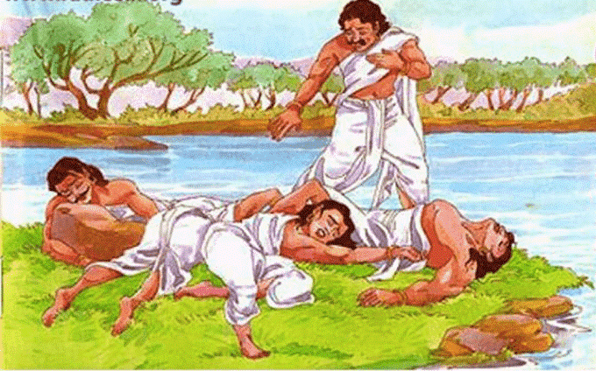

He suffered the same fate as Nakul. Yudhistira dispatched Arjuna and subsequently Bheem after Sahadev failed to return. Arjun and Bheem suffered the same fate as the other brother’s. When the four brothers did not return, Yudhistira became very concern, and he proceeded to find out what had happened to hit brothers. He went the same direction as his brothers. When he got close to a pool, he noticed his four brothers laying motionless on the ground, seemingly died. He was taken aback. He went into the water to quench his thirst before learning what had happened to his brothers.

Immediately, an unidentified voice cautioned him not to drink water before answering its questions, or he would suffer the same fate as his brothers who did not answer the question before drinking.

Yudhistira immediately recognised this as Yaksha ‘s words and deduced what had happened to his siblings. Then he instructed the bodiless voice to inquire. The questions were asked in fast succession by the voice. The questions are ………….

***What rescue man in danger ?***

***Courage.***

***What is more nobly sustaining then the earth ?***

***The mother who brings up the children borne ,is nobler and more sustaining than the earth ?***

***The mother who brings up the children she has borne , is nobler and more sustaining than the earth.***

***What is higher than the sky ?***

***The Father.***

***What is fleeter than the wind ?***

***The mind.***

***What is the more blighted than withered straw ?***

***A sorrow stricken heart.***

***What befriend a traveller ?***

***Learning.***

***Who accompanies a man in death ?***

***Dharma.***

***What is the biggest vessel?***

***The earth.***

***What is happiness?***

***Happiness is the result of good conduct*.**

Thus, the Yaksha posed many questions and Yudhistira answered them all.

**Yaksha:** “ I am pleased with your wisdom, Yudhistra. I will bring all your brothers to life”.(Happy)